**АНОТАЦІЯ**

Зміни в навчальному процесі висувають нові вимоги до діяльності вчителя, яка орієнтована на учня і це викликає необхідність по новому підійти до проблеми формування навичок читання на початковому етапі.

Актуальність проблеми полягає в тому, щоб через упровадження сучасних методик сформувати в молодших школярів навички спілкування в усній та писемній формах. А так як читання іноземною мовою, як комунікативне уміння і засіб спілкування є важливим видом мовленнєвої діяльності, яке включає техніку читання і розуміння того, що читається, тому ведуча педагогічна ідея полягає в тому, щоб навчити учня початкової школи техніці читання на добре відомому лексичному матеріалі з елементами новизни. Сформувати в учнів зорографічні та слухомоторні зв’язки, які сприяють миттєвому впізнаванню і розумінню слів, співвідносити їх із значенням інших слів. Об’єднувати слова в синтагми, синтагми в речення та речення в більш смислові утворення.

Зміст і цінність міні- підручника «Easy Reading» в тому, що підібрані матеріали відповідають чинній програмі.

Підручник буде корисний для вчителів та учнів на початковому етапі вивчення англійської мови.

Упорядники: члени творчої майстерні вчителів англійської мови Калуського району:

1.Яковина З.Я. – вчитель англ. мови Мостищанської ЗОШ І-ІІ ст..

2. Бойко Р.В.- вчитель англ. мови Пійлівської ЗОШ І-ІІІ ст.

3. Войтюк В.О. - вчитель англ. мови Підмихайлівської ЗОШ І-ІІІ ст..

4. Лесів Г.О. - вчитель англ. Мови Зборянського НВК

5. Атаманчук Н. І. - вчитель англ.. мови Довго- Войнилівської ЗОШ І-ІІІ ст.

6. Клебан Т. С. - вчитель англ.. мови Новицького НВК

**A [ei]**

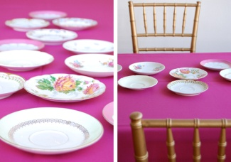

plate race

table name

cake take

game make

lake Kate

snake bake

Bake a cake; A plate and a table; a snake and a lake;

She bakes a cake.

She came for a cake.

A plate is on the table.

A cake is on the plate.

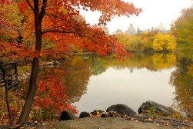

**Pat-a-Cake**

Pat-a-cake, pat-a-cake, baker's man,  
Bake me a cake as fast as you can.  
Roll it, and prick it, and mark it with a "B"  
And put it in the oven for baby and me!

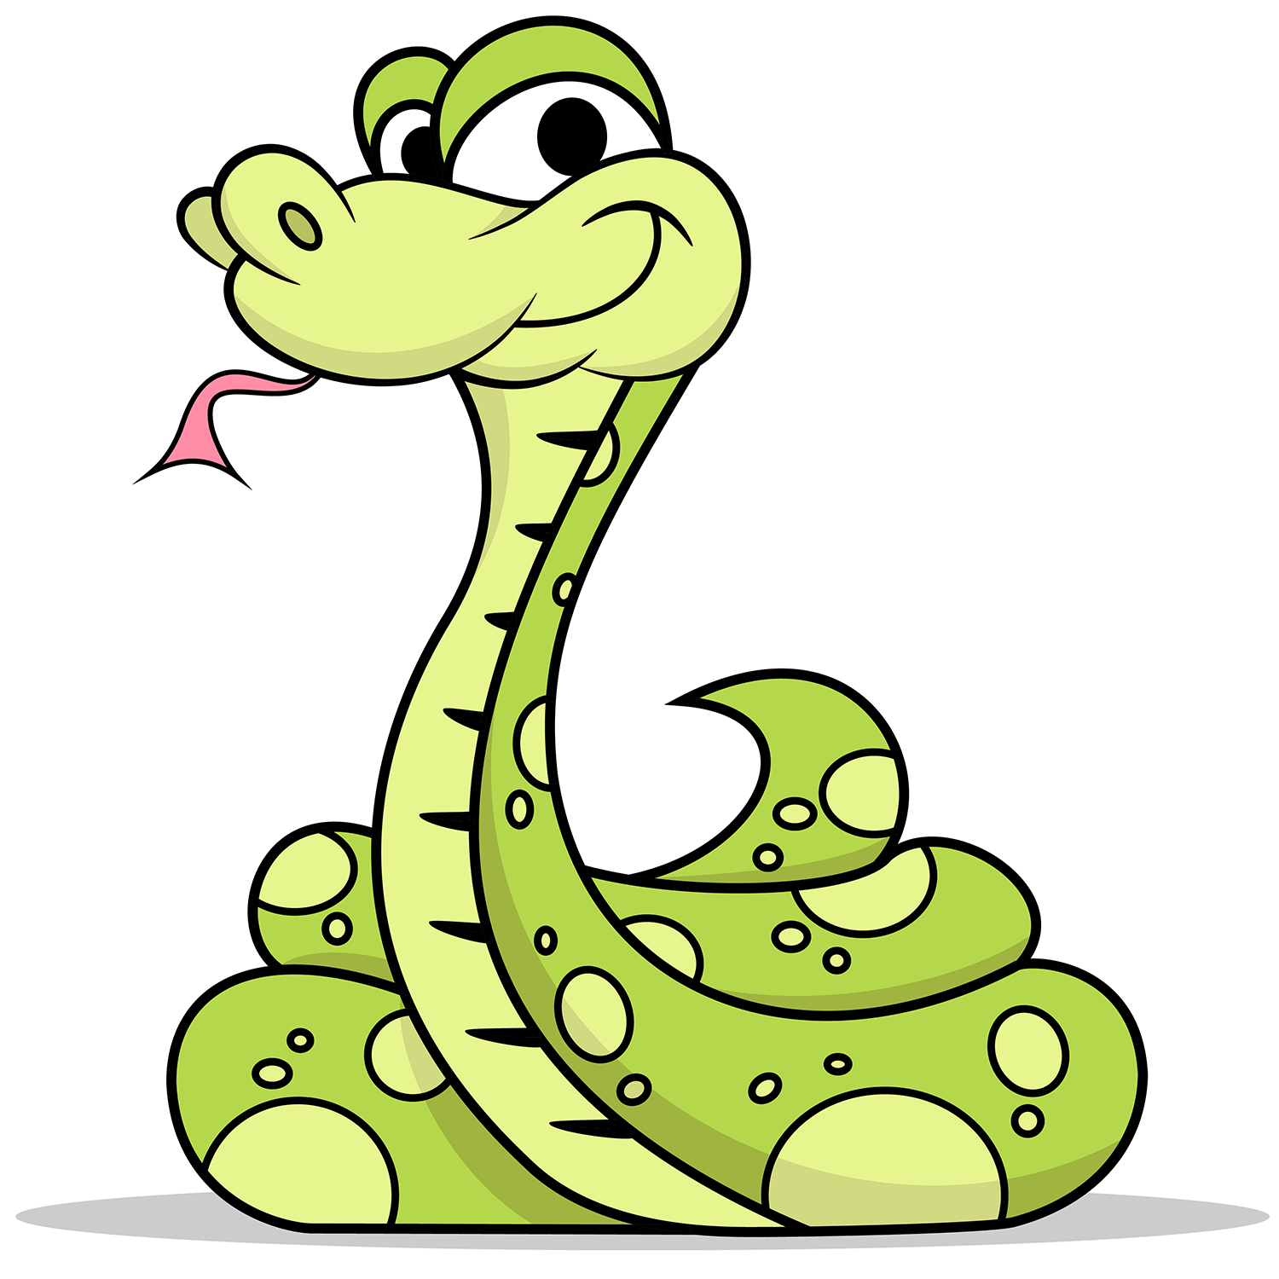

This is a snake,

It lives by a lake,

It is on a log,

And looks at a frog.

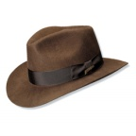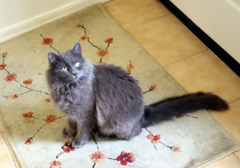**A [æ**]

bag cat

man pan

sat cab

hat mat

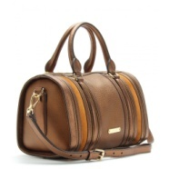fat ant

lamp rat

A bad cake, a bad hat, a bad apple, a bad cat, a bad mat, a bad lamp. A cat and a mat; a lamp and a table; a rat and a cat; a bag and a hat.

A lamp is on the table.

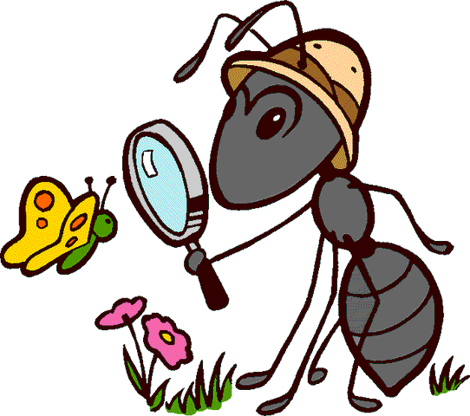She has a cat.

She has a hat.

A rat is sad.

An ant in a hat.

A fat black cat

Sat on the mat

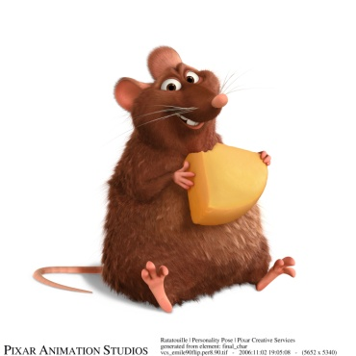And ate a fat rat.

Zac

Zac is a rat. Zac sat on a can.

The ants ran to the jam.

Zac had a pan. Zac had a fan.

The ants ran and ran. Zac had a nap.

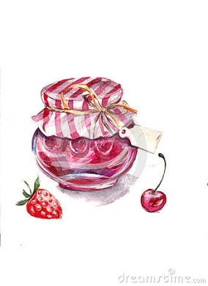**Ar [a:]**

car arm

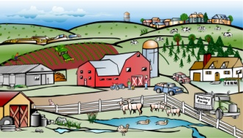park far

dark star

mark jar

shark bar

farm warm

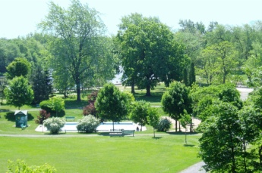a jar of jam; a dark car; a big star; an old farm; a smart shark;

Carla sees a smart shark. Mark lives on a farm.

Carl likes a car.

Mark sees a jar of jam. I see a dark star.

We go to a park.

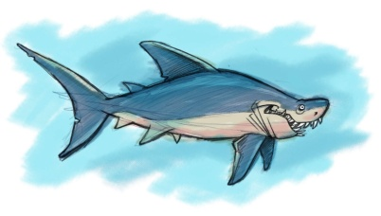Where a dog run and bark.

It’s a shark

Swimming in a park

In the dark

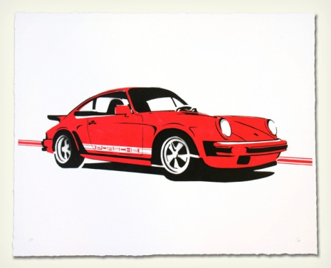For a lark.

Car Race

Carla and Mark have go carts. Carla is number five. Mark is number seven. "Let's race," says Mark. Get ready, get set, go! Carla can't pass Mark. Mark hits a bump. Carla is in the lead. Carla wins! She is the star.

**ay, ai [ei]**

day tail

gay hail

may sail

pay pain

play paint

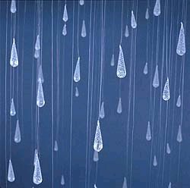say rain

a rainy day; play today; may pay; go away; a long tail;

They say: ‘May we play on a rainy day”.

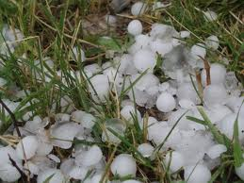What a happy day today.

Day today.

The children sing and play.

Sing and play.

Oh, the happy day, happy day.

Rain, rain, go away,

Come again another day.

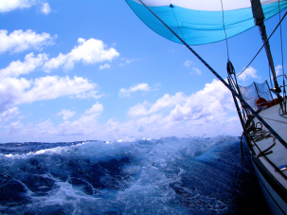Little Tommy wants to play.

Ray

Ray is a whale. Ray has a long tail. Ray is standing on its tail. Ray is wearing a sail. A whale Ray has a long way today. Ray sails to a new bay.

**all [ɔ:l]**

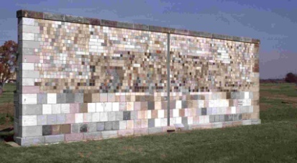all call

ball pall

small mall

wall stall

hall fall

tall gall

a small ball; a red ball; a tall doll; a green wall; a big hall; a small hall; a big mall;

I have a red ball. Her ball is the best of all. There is a big hall in a new mall. Paul is very tall.

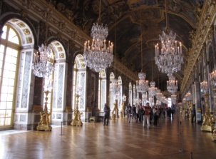

.

He has a ball,

She has a ball,

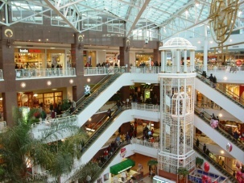It has a ball,

They have red balls

Wally and Elli

Wally has a small red ball. Elli has a big blue ball. One day they went to a big mall. Wally and Elli went to a hall. Wally wanted a big green ball. Elli wanted a big red ball. Now they have new balls and play with them all the day.

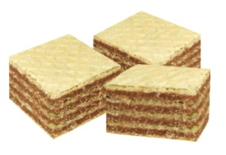**wa [wɔ]**

wash war

watch warm

water walk

was want

waffle wart

warm water; warm waffle; a long walk; a short walk; a big wart.

They wash a warship by warm water. Wally wants warm waffles. We want for a walk. She has a big wart. I want to wash my Irish watch.

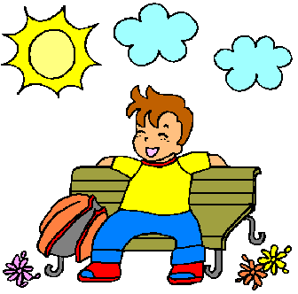

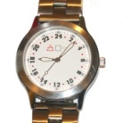

While we were walking,

We were watching

Window washers wash

Washington's windows

With warm washing water.

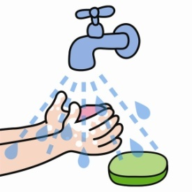



Dialogue.

- Hi, Wally!

- Hi, Willy!

- Where do you want to go?

- I want to watch warships in a warm Washington.

**Aw [ɔ:]**

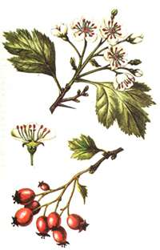caw straw

daw paw

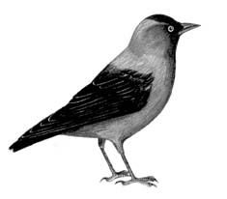haw raw

jaw saw

law taw

draw claw

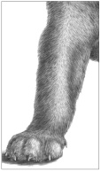

a big saw; a strict law; a small paw; soft straw;

A daw saw a haw. A cat has small paws. They sleep on straw.

Paul called. Paul called from the hall.

When I went to Warsaw, I saw a saw that could outsaw any saw that I ever saw. Now, if you go to Warsaw and see a saw that could outsaw the saw I saw, I'd like to see your saw saw.

Tommy Frot, a man of law,

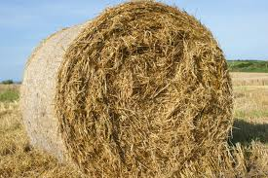Sold his bed and lay upon straw,

Sold the straw and lay on the grass

To buy his wife a looking glass

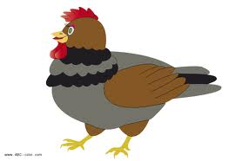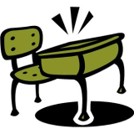**E [e]**

Pen leg

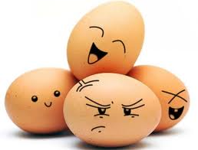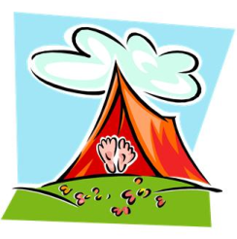Ten pet

Net hen

Bed wet

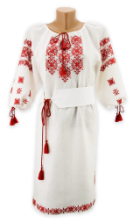red left

Egg des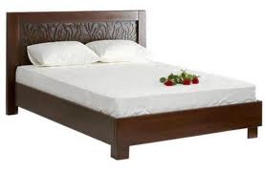k

Dress tent

A Pen and a desk, a wet pet, a left leg, a red hen, ten men, a big net, a bad bed, to sell a hen, a little egg.

It’s a net. It’s a left leg. It’s a pen and a desk . Tom has a pet. His pet is red. It’s ten. Her dad is a vet.

It is Ted. Ted has a pet. It is a cat. It is Fred. Fred is red. Ted and Fred are wet.

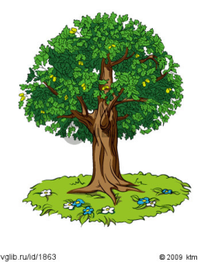**ee [i:] e [I:]**

tree Pete

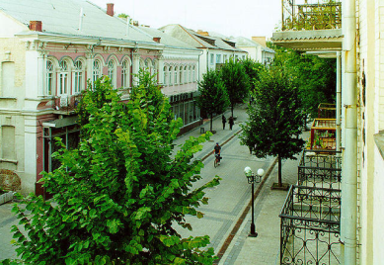free me

green he

street be

peel Steve

steel we

see

sleep

meet

a green tree, he and we, his street,

Let’s meet at three. It’s a green street. He is free. Pete sleeps. I see a green tree.

Denise sees the fleece,  
Denise sees the fleas.  
At least Denise could sneeze  
and feed and freeze the fleas.

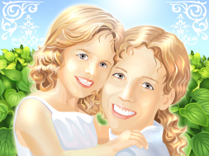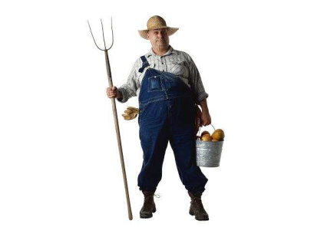**er [ ε:]**

sister father

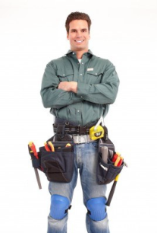winter mother

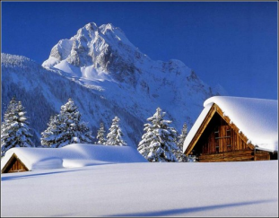her brother

worker corner

water member

farmer dinner

Her mother, his father, my sister, a farmer and a worker, steel water, cold winter.

Her father is a farmer. His brother is a worker. It’s a cold winter. It’s dinner.

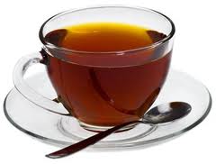**ea [i:]**

teacher sea

C:\Program Files\Microsoft Office\MEDIA\CAGCAT10\j0301252.wmfread leaf

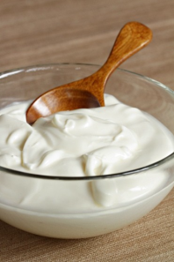clean season

please dream

speak tea

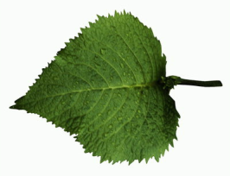eat cream

hot tea, her dream, cold season, read and speak, his teacher, a green leaf, a big sea

His mother is a teacher. He has a dream. I can read and speak. It’s hot tea. It’s a green leaf. It’s a big sea.

Winter is a cold season. I clean a desk. We eat cream.

A sailor went to sea To see, what he could see. And all he could see Was sea, sea, sea.

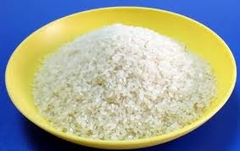**Ii[ ai] –ай Yy[ai]-aй**

like - by

write - my

rice - cry

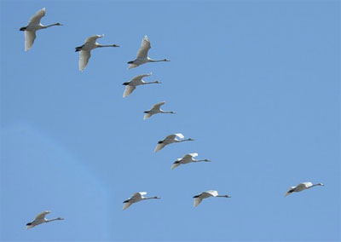tie - fly

ice - shy

nice - fry

bite - sly

invite – lyme

Mike likes ice-cream.

Ike is nice and wise.

I smile looking at a kite.

Michael writes nicely to invite Mike.

Hi! Don't bite Risa!

My mice are white and sly.

Don't cry! You'll fly by plane next July.

Bye, Mike, Risa and Ike!

It is nice. Its name is Spot.

Spot can run. Spot can jump.

I like my dog.

**ir [ə:]**

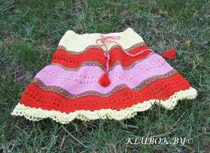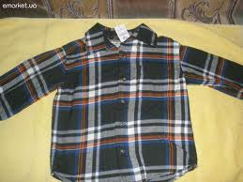girl bird

first thirsty

shirt skirt

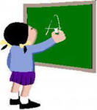

I see a girl .

She is in the first form.

The girl has a skirt and a shirt on. She can .

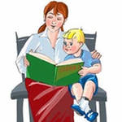My name is Petryk. This is my mother. Her name is Sveta. She is thirty. She lives in Kyiv. She reads a book for me. I love her very much.

**Oo [ou]**

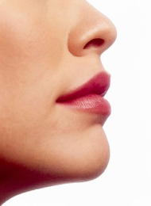rose - home

nose - go

note - no

rope - pose

close - cone

Joe, go home alone.

Joel hoped to close a stone door.

Ho, hoe those roses!

Joseph codes his note because of a foe.

Oh, no, Rosie's nose is like a cone!

**oo [u]**

book room

broom look

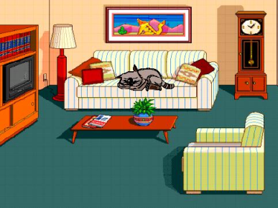 good hook

took wood

a good room, my spoon, an old broom, my book

**or [ɔ:]**

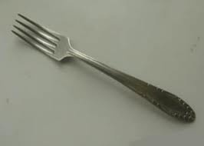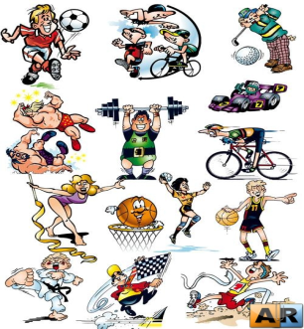corn born

form storm

for sport

horn short

fork

First form, a short skirt, good sport, my form, a big fork

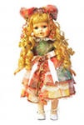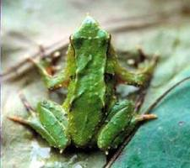**O[ɔ]**

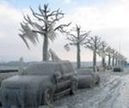Hot not

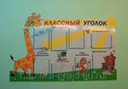Spot doll

Frog frost

Lot poster

A big dog, a a hot pot, red spot, a winter frost

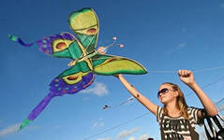**Yy**

**у відкритому складі ― [ai]**

m**y** fl**y**

wh**y** t**y**pe

bu**y** st**y**le

sk**y** cr**y**

b**y**e-b**y**e tr**y**

a blue sky fly a kite My pen, a blue sky, fly a kite,

It is a spring. The sky is blue. The bird are flying in the sky.



Why do you cry, Willy?  
Why do you cry?  
Why, Willy?   
Why, Willy?  
Why, Willy? Why?

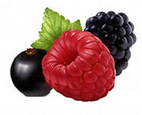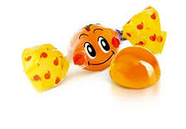 **у закритому складі ― [I]**

famil**y**  part**y**

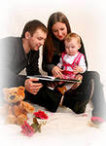berry carr**y**

candy happ**y**

man**y**  rain**y**

funn**y**  angr**y**

sunn**y** read**y**

A big family, a happy family, a very big family, a red berry, a very little berry, a little candy, a very bad candy.

It is a very happy family. I have a large family.

Vicky has a big berry. A little candy is on the table.

I have a candy and a berry.

Vicky has a candy. It is very little. Her candy is in her hand. Andy has a berry. It is very big. His berry is in his cup.

**на початку слова перед голосною— [j]**

**y**es **y**ou

**y**et **y**our

**y**ard **y**oung

**y**ellow **y**outh

**y**ear **y**esterday

A new yard, a big yard ,a small yard.

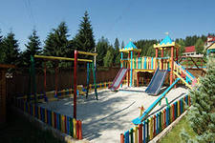

The New Year, a young girl, a young boy, a yellow pencil, a yellow ballon, a yellow sun.

I have a yellow ball. I play in the yard.You have a ballon too. Your ballon is red.You may play with me.

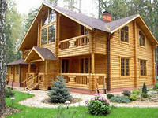**ou [** **au** **]**

r**ou**nd,c**ou**nt, h**ou**se, s**ou**nd, cl**ou**d, gr**ou**nd

**[** **ju:]**  y**ou,**

 **[** **o: ]** y**ou**r, f**ou**r

**[ au]**  s**ou**r, sh**ou**t, tr**ou**sers

**[ /\ ]** c**ou**sin , y**ou**ng

My house, a grey cloud, a round table, a lovely sound, a young girl, your cousin, his trousers, four pens.

I have a house. It is big and nice. There are four rooms on the ground floor. There is a round table in the our house.

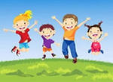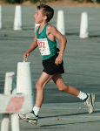**U [ ^]**

bus run

but under

lunch cup

umbrella jump

plus gun

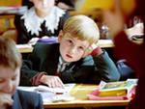

**u [u:] [ju:]**

blue tube

glue cute

true tune

pupil duke I can run, I can jump,

student tulip But I cannot fly

Doggy- doggy, come to me

Let us play under the tree

.

.

**SHORT TEXTS FOR READING**

**My Room**

I have a room. My room is not big. I have a desk,a bed and chair in my room.The desk is on the floor in the middle of the room.The bed is on the left hand of the desk.The chair is at the desk. I have a lamp in my room. The lamp is little. It is in the middle of the desk.

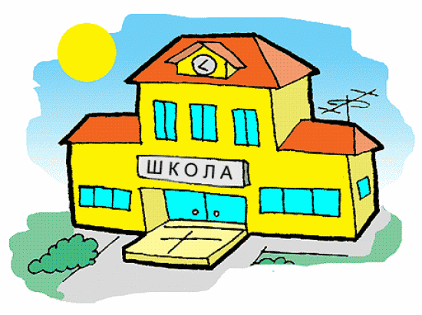

**My School**

My school is very big and nice.You can see many trees and flowers near the school.There are many classrooms in my school. They are big,clean and light.We have many good teachers in our school.

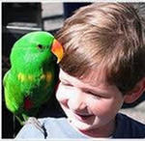 **TOM**

This is Tom. Tom is a big boy. He is ten. He lives in London. Tom likes animals. He has a dog, a cat, and a bird. He has many fishes too. Cat likes milk and his dog likes fishes. Tom likes to play and run with his

**My Family**

Hi! I’m Julia. I am ten. I am a pupil. I am from England. I live with my family in a big flat. I have a family. It is big. I have mum, dad, a brother and grandparents. My mum Emily is a doctor. My dad Steve is a teacher at school. My grandparents are retired. My sister is three. She goes to a nursery school. We are a happy family.

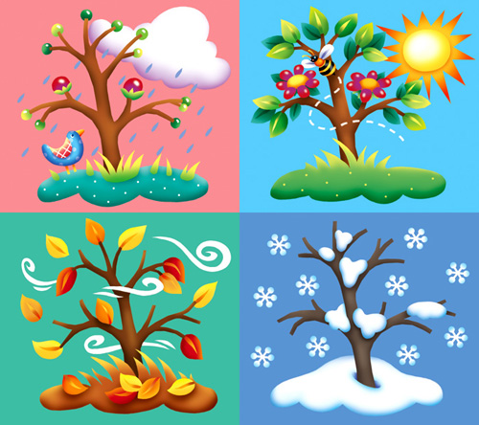**Seasons**

Spring, summer, autumn and winter are four seasons of the year.

It is warm in spring. The grass and the leaves becomes green.

It is hot in summer. The sun shines in the sky. Children have holidays.

It often rains in autumn. It is cold and foggy.The leaves are red, yellow and brown.

It is very cold and frosty in winter. It snows and the cold wind blows.

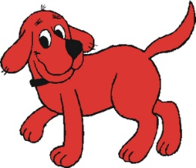 **My Pet**

I have a pet. It’s a dog. Its name is Rex. Rex is very clever. Rex is a big dog. It has red fur and long tail. Rex has long ears and big eyes. Rex is a funny dog.

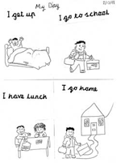 **My Day**

I am Dave. I am 10. I get up at seven o’clock. I wash, dress and have breakfast. Then I go to school. I have 4 or 5 lessons every day. I come back home, have a rest and have lunch. Then I do my homework and read a book. I go to bed at ten p.m.

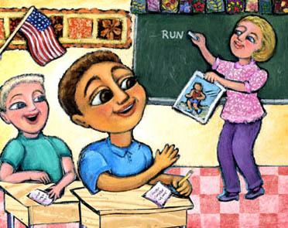 **OUR ENGLISH LESSON**

We have our English on Mondays and Thursdays.

At the English lesson we read and write in English. We speak English, too. We read and learn new words. We read texts, too. We usually write on the blackboard. We speak about our school, our lessons, our family and friends. We all like our English lessons.

**Letters to my Friends**

Hello, my friend!

My name is Bob. I`m from England. I’m a pupil. I`ve got a family. I`ve got a friend. His name is Tom. He is not from England. He is from America. He is not a pupil. He is a teacher. I like my friend.

Bye. Bob

**Hello, my friend!**

My name is Liz. I am from America. I am a pupil and you? I have got a brother and a sister, and you? My sister is a pupil. Her name is Sally. My brother is a doctor. His name is Bob. I love my family.

See you!

Liz

**Hello, my friend from Africa!**

My name is Vova. What is your name? I’m eight. And you? How are you? I`ve got a dog. He is very big. His name is Rex. He is brown and black. I like to play with Rex. Rex doesn`t like to jump. He likes to run or to sit under the table. Rex likes to play with me, too. I love my dog. I want to have a cat, too.

Have you got a dog? What is its name? What colour is it? Is it big or little? Do you like to play with it?

Bye.

Vova

Hello!

I`m Rita. My friend Alina has a grandfather. He is fifty six. He is a doctor. Alina and her father are at home. They read a book.

Have you a grandfather?Write me about your grandfather.

Bye.

Rita

**Nick and His Pets.**

Nick is a little boy. His parents are farmers. They have a farm. They have got many domestic animals and birds on their farm.

Nick has three pets: a dog, a cat, and a parrot. His pets are very funny. The dog`s name is Chance. His tail is short. His ears are very long. He can play football with Nick. Chance is a friendly dog. The cat`s name is Alice. She is lazy and cunning. She cannot play football but she has three kittens. The parrot`s name is Chat. He is a bright and clever bird. He can talk and bark like a dog.

Nick`s pets are good friends. They are nice and clever. They love their little master.

**A Good Mother**

My grandmother lives in a nice big house. She has got many domestic animals and birds in the yard. Granny`s cat Moorka is a good mother. She loves all the babies: kittens, puppies, chickens, rabbits. She has got three kittens. These fluffy babies are very funny. They always want to eat. Moorka gives them milk. But look! This is not a kitten. This is a puppy. Moorka gives him milk too.

**HIS SCHOOL SECRET.**

He has a secret. He keeps his secret. He shares it with nobody. He tells it to nobody. A secret is a secret. He loves his teacher. That is his secret. His teacher is beautiful. She is smart. She likes him too. She gives him A’s on his homework. She gives him gold stars for his class work.

**SHE PLAYS THE PIANO.**

She sits down on the bench. It is a piano bench. She puts her fingers on the piano keys.

She plays a song. The music sounds good? Her dog howls to the music. Her cat leaves the room.

She plays the song again. Her dad enters the room. He sits down and listens.

**HE SKATES ON THE POND.**

It is winter. It is early morning. He goes to the park. He puts on his ice skates. He skates on the pond. He skates round and round. Nobody else is on the pond. He has it all to himself. It is quiet on the pond. The only sound is his on the ice.

**GREENFIELD**

Greenfield is a small village in England. It's not far from Manchester. There are five buses to Manchester every day, but there is only one train. There are not many people on the train at five o'clock in the morning.

The village is nice. The church is in the middle of the village on the square There are many other buildings in the square. There is a bank, a post office a bus station and a police station. The library is behind the police station. Then is a small river in Greenfield and there is a bridge across the river.

**Little Bunny**

I am a bunny. My name is Nick. I live in the forest. My house is in the hollow tree. In spring I like to pick flowers. The flowers are very nice, sweet and tasty. In summer I listen to the birds. In autumn I see bright leaves on the trees. In winter I dream about spring.

Into My Vocabulary

|  |  |  |  |
| --- | --- | --- | --- |
| № | Слово | Транскрипція | Переклад |
|  |  |  |  |
|  |  |  |  |
|  |  |  |  |
|  |  |  |  |
|  |  |  |  |
|  |  |  |  |
|  |  |  |  |
|  |  |  |  |
|  |  |  |  |
|  |  |  |  |
|  |  |  |  |
|  |  |  |  |
|  |  |  |  |
|  |  |  |  |
|  |  |  |  |
|  |  |  |  |
|  |  |  |  |
|  |  |  |  |
|  |  |  |  |
|  |  |  |  |
|  |  |  |  |

**Зміст**

1. Анотація
2. Вправи на читання 1
3. Додаткові тексти для читання 21